**LAB 4 - Due: Sunday at Noon**

**Scenario**

You are hired to develop a normalized data model starting with a sample document (see table below). The sample document is a digital bill summary sheet that Orange Digital Company is currently using to track the telephone, internet connection, and cable usage for its customer accounts. Orange Digital Company wants to build a small database to store and retrieve this information.

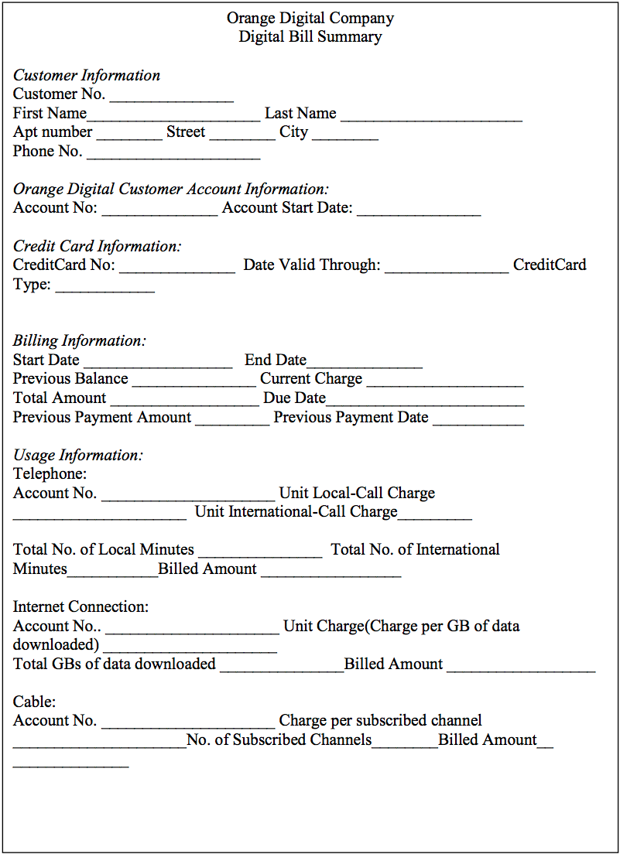

In addition, Orange Company follows these business rules:

1. Each customer must have at least one account with Orange Digital Company.
2. Each customer must have at least one credit card for bill payment.
3. Each account must have at least one of the connections, e.g., telephone/internet / cable.
4. Telephone account number is not the same as Internet connection account number or cable account number.
5. Each telephone account number is associated with one and only one customer account number.
6. Each internet connection account number is associated with one and only one customer account number.
7. Each cable account number is associated with one and only one account number.
8. Current charge is the summation of telephone, internet connection and cable billed amounts for the billing period. There are no adjustments from previous cycles.

**Instructions**

You will **use MS Access to complete this assignment**. You will go through the steps that we used to demonstrate normalization in class. Basically, take all given data fields in a 1NF form and then move forward by normalizing this model to 2NF (second normal form), then to 3NF (third normal form).

Please pay attention on the following requirements.

1. Start with 1st NF by using Customer No., Orange Digital Customer Account No and Billing Start Date as a composite PK.
2. When creating the 2nd NF, explain what partial dependencies you have found and how you removed them.
3. When creating the 3rd NF, explain what transitive dependencies you have found and how you removed them.
4. Establish relationships between entities. Give the relationships appropriate names (show forward verb phrases only) and recognize the associations (foreign keys).
5. **Your final database design must be in the 3NF**. Feel free to create new tables or attributes when necessary.
6. Please enter sample data (***at least 3 records***) in the final ACCESS table. ***One of the records should contain your name.***

**Submission Instructions**

Please submit your lab report (including the ERDs and screenshots) in **one MS Word file** (.docx) to BlackBoard. Name your file in this format “IST659-Lab4-Lastname-Firstname.docx”.

**Due date:** The lab report is due on **Sunday, Noon**

**Grading Criteria**

* Provide 1NF, 2NF, and 3NF ACCESS relationship-diagrams – 2.5 pt.
* Completed and correct dependency lists - 1.5pt
* Complete Cardinality, correct identification of keys, no composite or multivalued attributes – 1pt